Output data Problem with rfft_fr16(…)
- input data in[] is set to :
Input data
{ 46 , 40 , 46 , 44 , 40 , 42 , 52 , 40 , 38 , 44 , 46 , 50 , 46 , 36 , 40 , 44 , 46 , 48 , 46 , 42 , 44 , 42 , 40 , 36 , 40 , 40 , 38 , 44 , 46 , 42 , 48 , 42 , 44 , 174 , 204 , 174 , 78 , 108 , 126 , 94 , 72 , 68 , 60 , 46 , 28 , 18 , 40 , 40 , 48 , 54 , 48 , 48 , 42 , 46 , 44 , 32 , 40 , 34 , 30 , 44 , 52 , 54 , 62 , 50 },
It looks like this:
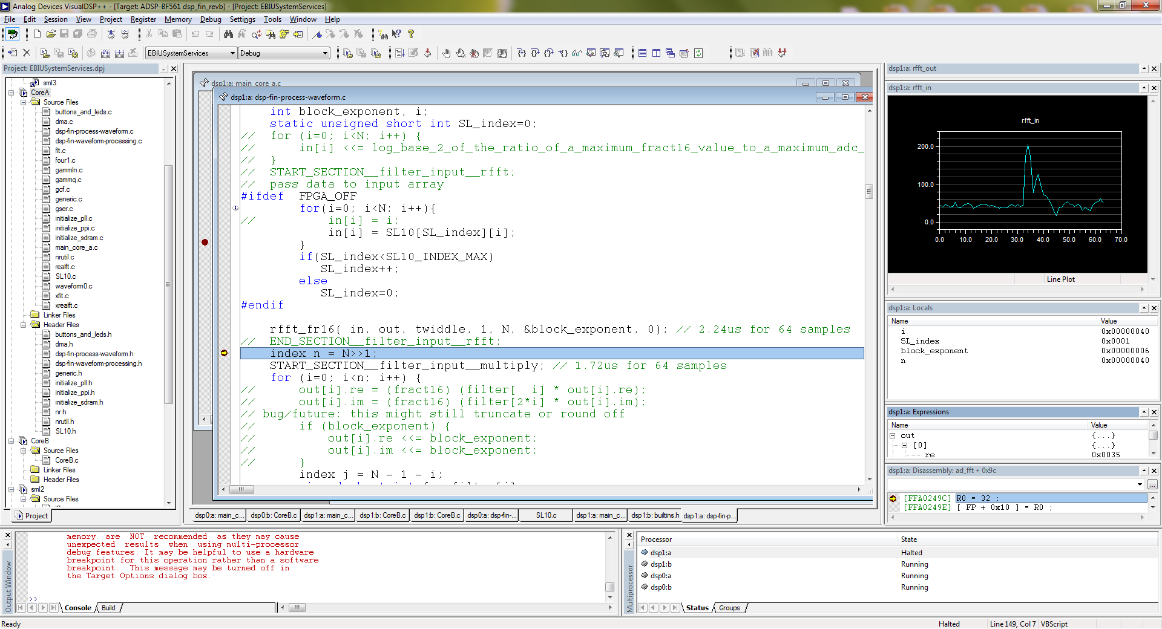

Out[] data
- It is passed to rfft_fr16( ) function
The output data value is like following:
